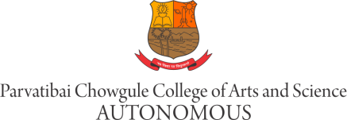

Applications are invited for the following post

M03. Advisor at the Writing Centre (Contract) – 1Post

Job Description: To work on one–to-one basis with students in all stages of writing process such as: generating ideas, creating an outline, polishing a draft, referencing and information searching and to teach academic writing courses to students as a part of the curriculum.
Working closely with faculty members of various departments in order to address the writing needs of departments.

Qualification: Postgraduate degree from recognized University in English with minimum 55% marks .

Age: Below 45 years

Applicants should compulsorily fill the On-Line Application Form available on College website www.chowgules.ac.in under >> Careers >> Employee Form and send the certified photo-copies of the statement of marks from S.S.C. onwards by post. Direct application will not be entertained. The link will be open only for 10 days from the date of advertisement.
Applicants should bring Original Certificates, at the time of interview.

Date: 17/08/2021. Principal

