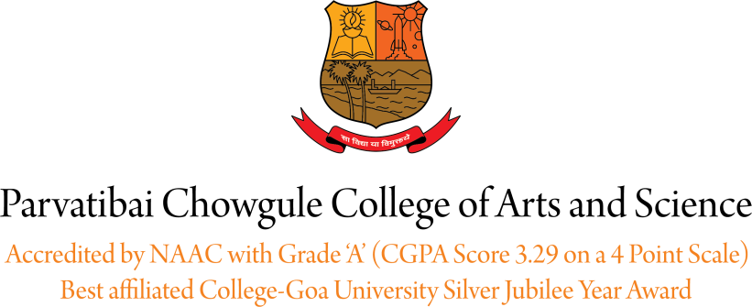

WALK IN INTERVIEW

WANTED Assistant Professor for Self financed Programmes for the academic year 2021 – 2022 for the following:

Sr. No : CONTRACTUAL POST
- Psychology ( PG ) 1Post

LECTURE BASIS POST
- Information Technology ( PG ) 1 Post
- Environmental Studies Course ( UG ) 1 Post
- Statistics Course ( UG ) 1 Post

Minimum Qualifications:
- Master’s degree with 55% of marks (or an equivalent grade in a point-scale wherever the grading system is followed) in a concerned/relevant/allied subject from an Indian University, or an equivalent degree from an accredited foreign University.

- Must have cleared the National Eligibility Test (N.E.T.) conducted by the UGC or the CSIR or a similar test accredited by the UGC like S.L.E.T/S.E.T. or have been awarded a Ph.D. Degree in accordance with the University Grants Commission (Minimum Standards and Procedure for award of M.Phil/Ph.D. degree) Regulations, 2009 or 2016 and the their amendments from time to time may be exempted from N.E.T./S.L.E.T./S.E.T.

Essential Requirements:
- Knowledge of Konkani & 15 Years residence Certificate issued by competent authorities of Government of Goa

Desirable Requirements: Knowledge of Marathi
Scale of pay, terms & conditions of service are those laid down by the Goa University, Directorate of Higher Education and other competent authorities, from time to time. Applicants, who are already employed, shall forward their applications through proper channel and shall account for breaks, if any, in their academic career.

Attend the interview along with an Application and all relevant documents on 23rd September 2021 at 2.30pm to 4.30pm. and 24th Sep, 2021 from 9.30am to 4.30 pm.

Date: 20/09/2021. Offg. Principal

