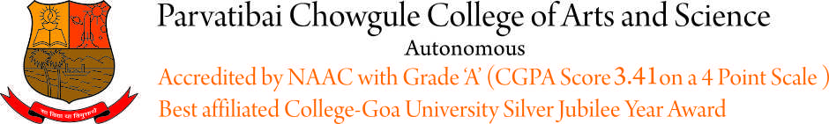
Advertisement No. NT/2020-21/04 Dated : 24/07/2021

Applications are invited for recruitment of the following
Group ‘C’ posts :

Post Code | Name of the Post | No.of posts
011 | Lower Division Clerk (for Examination Cell | 01

For detailed advertisement of all the above posts,
please visit government portal , www.goa.gov.in and
college website, www.chowgules.ac.in.

Last date to apply is : 8th August 2021

Dated : 24/07/2021 Dr.SHAILA R. GHANTI
Offg. Principal

