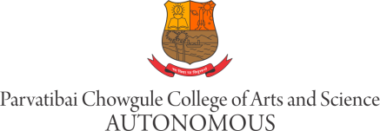

WALK IN INTERVIEW

M03 : Writing Advisor at the Academic Writing Centre (Contract) – 1 Post

Job Description:
To work on one–to-one basis with students in all stages of writing process such as: generating ideas, creating an outline, polishing a draft, referencing and information searching and to teach academic writing courses to students as a part of the curriculum.
Working closely with the faculty members of various departments in order to address the writing needs of departments.

Qualification: Postgraduate degree from recognized University in English with minimum 55% marks.

Age: Below 45 years

Applicants should fill the On-Line Application Form available on College website www.chowgules.ac.in under >> Careers >> Employee Form.

The link will be open only for 5 days from the date of advertisement.
Applicants should bring Original Certificates, at the time of interview.

Walk-in Interviews on 23rd September 2021 (Timings: 2.30pm to 4.30pm) at Parvatibai Chowgule college of Arts and Science (Autonomous) Margao, Goa.

Date: 16/09/2021. Offg. Principal

