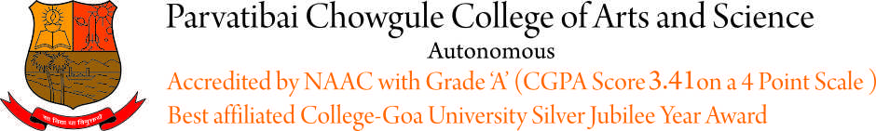

Advertisement No. NT/2020-21/04 Dated 23/07/2021.

Applications are invited by the Principal, Parvatibai Chowgule College, Gogol, Margao-Goa, for recruitment to the following group ‘C’ posts. The applicants should compulsorily possess (1) valid 15 years Residence Certificate in the State of Goa, (2) valid Employment Exchange Registration number/card.

Age 18 years and above and not exceeding 45 years of age (Relaxable for Govt. servants and reserved categories in accordance with the instructions or orders issued by the government.)

Candidates should apply On-Line Application Form available on College website www.chowgules.ac.in under >> Careers >> and send send self attested photocopies of statement of marks from S.S.C. onwards, computer literacy certificate and residence certificate, to the Principal, Parvatibai Chowgule College of Arts & Science, Autonomous, Gogol, P.O. Fatorda, Margao-Goa 403602. The last date to receive e-applications for the above posts is 08/08/2021.

Post  Code | Name of the Post | No.of posts | Period of Contract | Level of Pay | Educational Qualification
011 | Lower Division Clerk (for Examination Cell) | 01 | 11 months | ` 18,744.00 | Essential:  a.Higher Secondary School Certificate or equivalent qualification from a recognized institution.  2. Should be computer literate  3. Knowledge of Konkani  Desirable:  1. Knowledge of Marathi

Note : Date for Skill Test/Written Examination will be communicated on www.goa.gov.in portal as well as on College website- www.chowgules.ac.in. NO INDIVIDUAL INTIMATION WILL BE GIVEN.

ONLY ELIGIBLE CANDIDATES FULFILLING THE CRITERIA AS STATED ABOVE SHALL APPLY.

For further details or instructions or process of selection, result, etc., it is advised to review constantly updates on Chowgule College website www.chowgules.ac.in.

Dated : 23/07/2021 Dr. (Smt.) SHAILA R. GHANTI
Offg. Principal

