Steps to fill the Income form only for Second Year and PG part 2 students
- Login to UMS 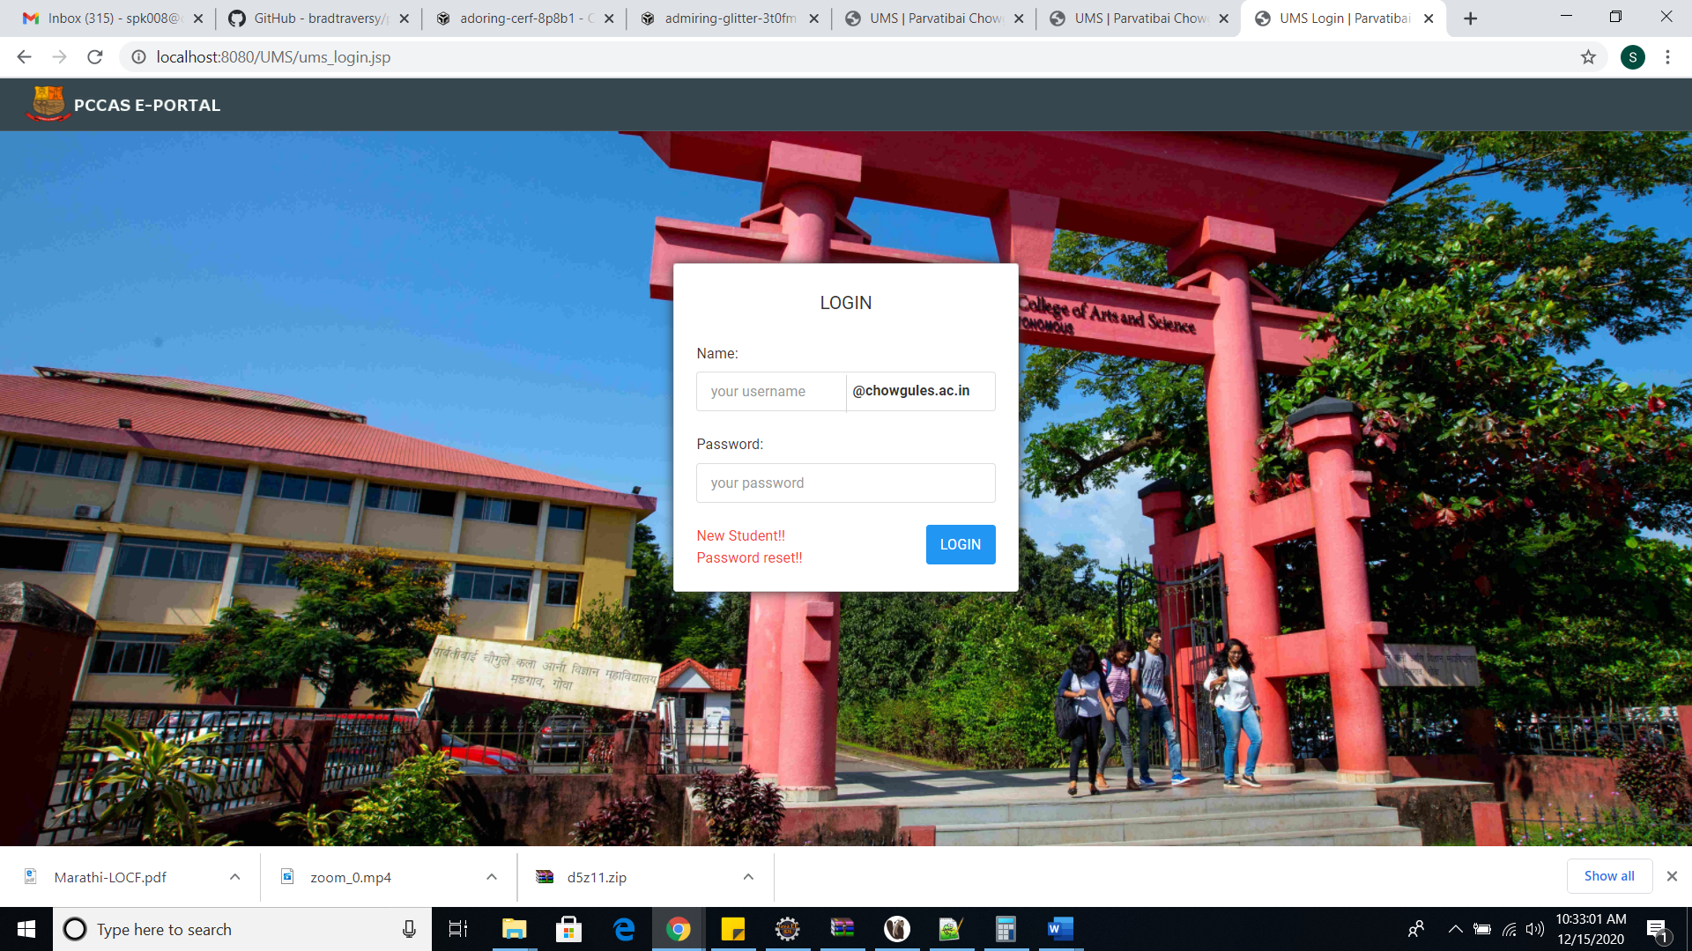

- After login go to top right corner and click on your name -> All Modules.
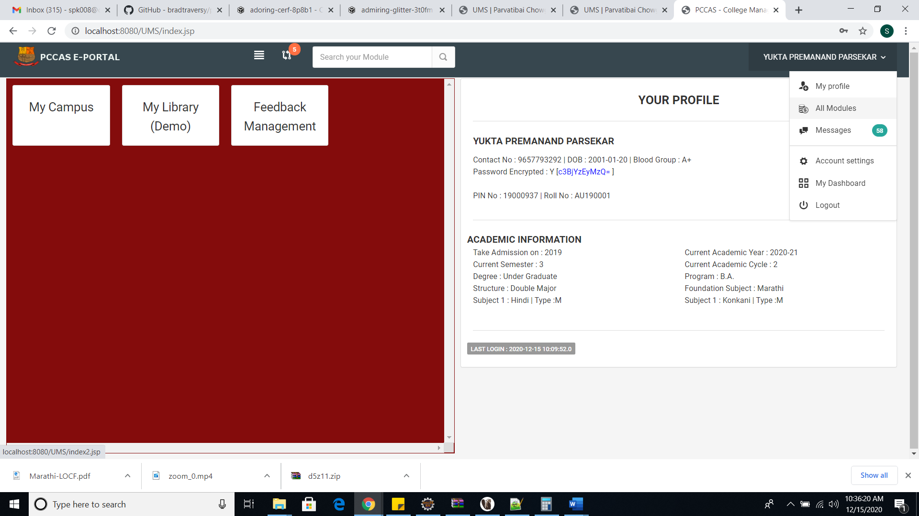

- Click on the Additional Detail Update
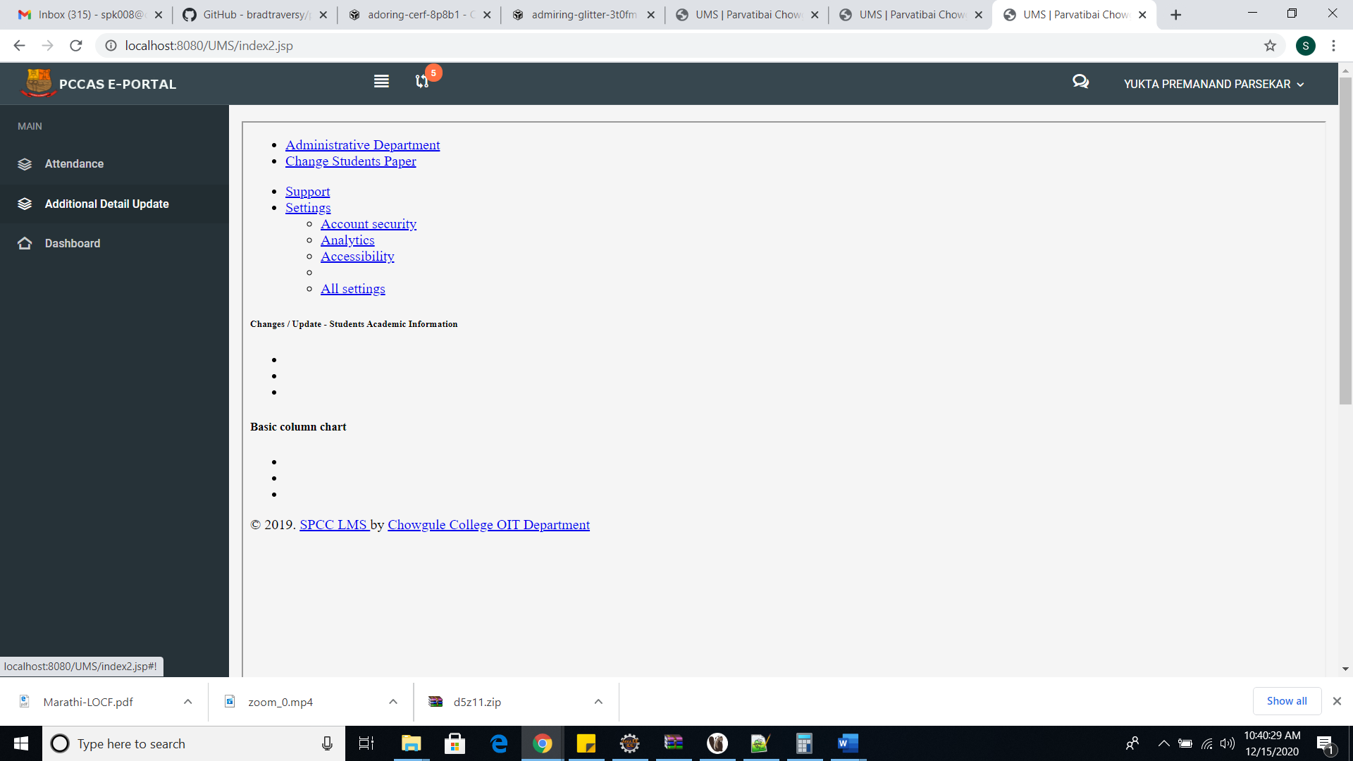

- Fill the University Registration Number (i.e., Permanent Registration No.) and Parents Income and click on submit button.
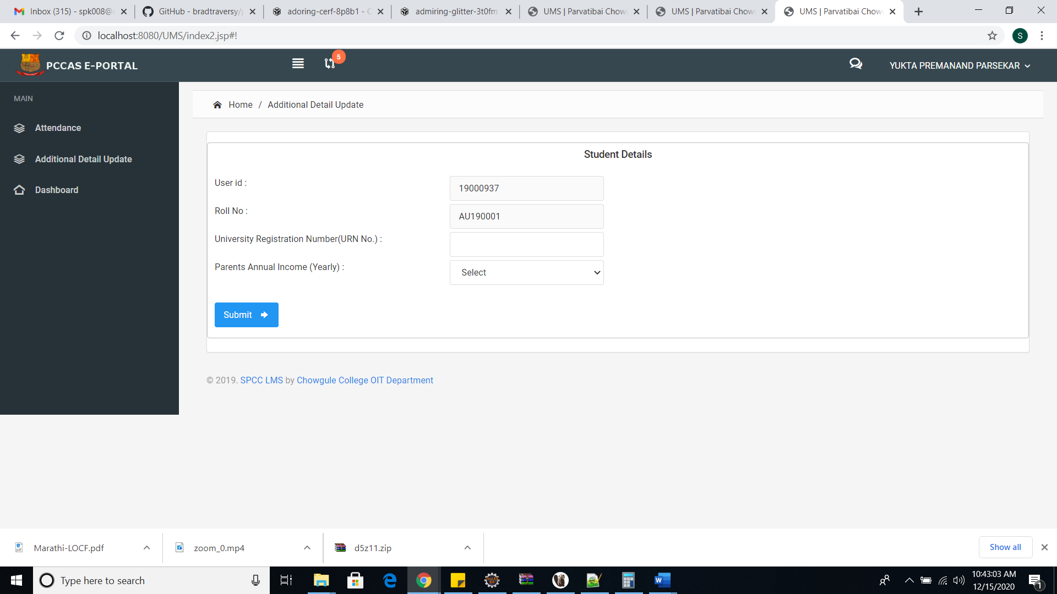

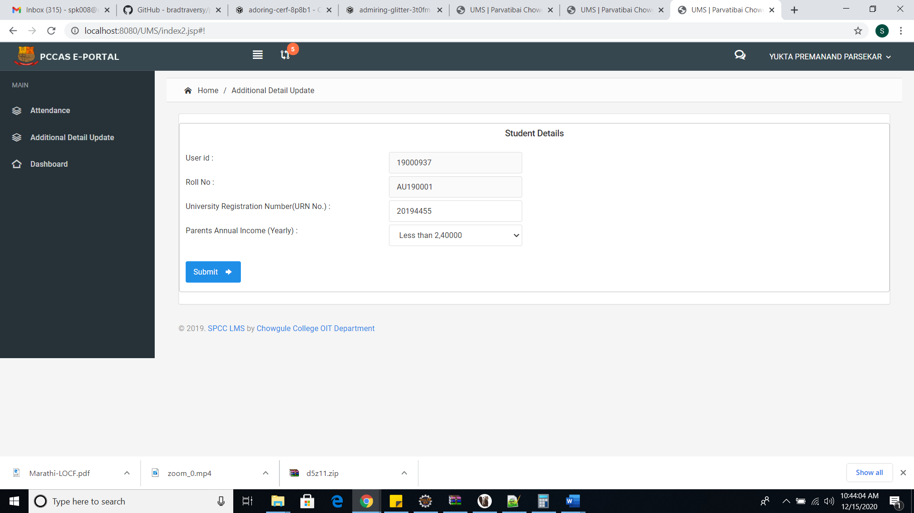

- After submission you will get message down that details submitted successfully.
