Manual to get Academic Information Details
- Login to UMS
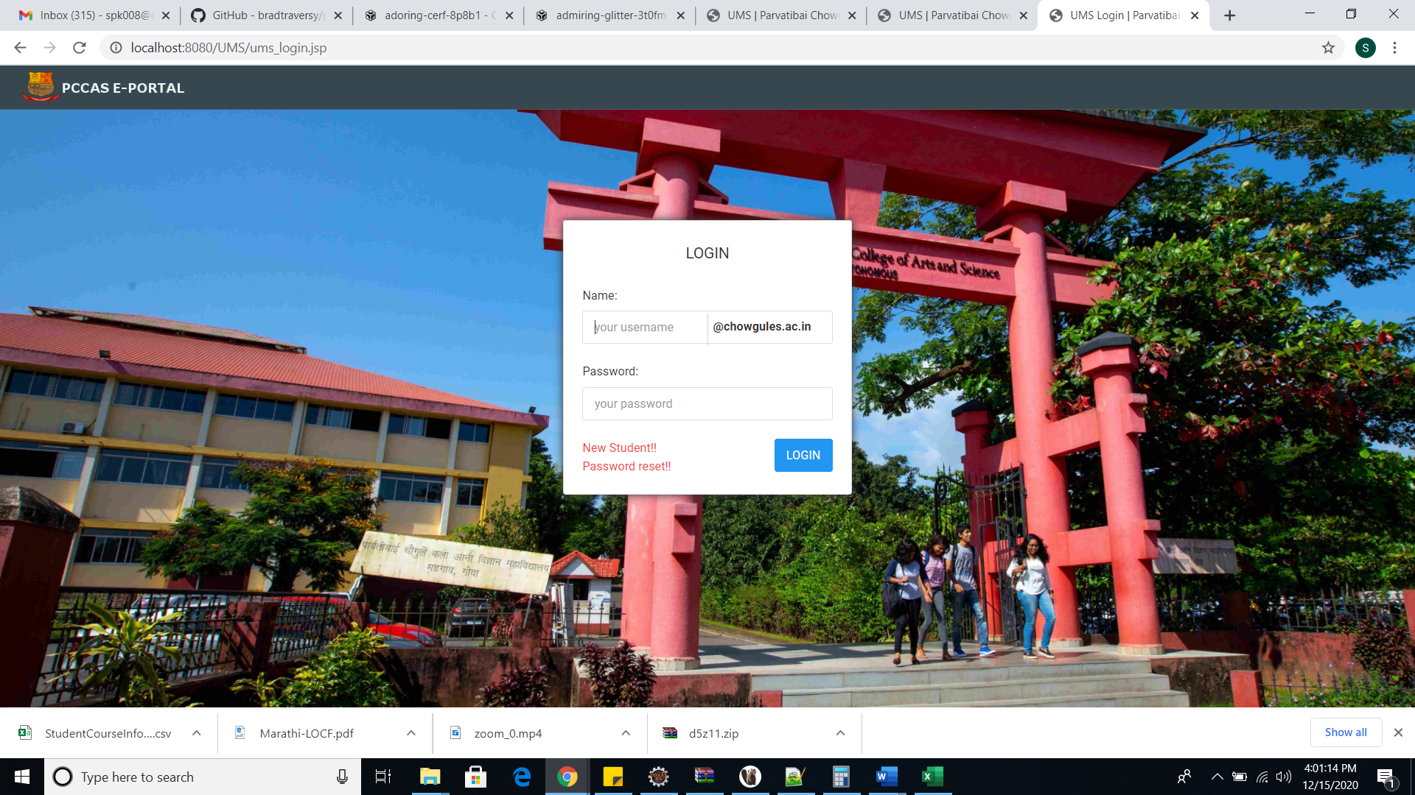

- Go to Classes /Attendance
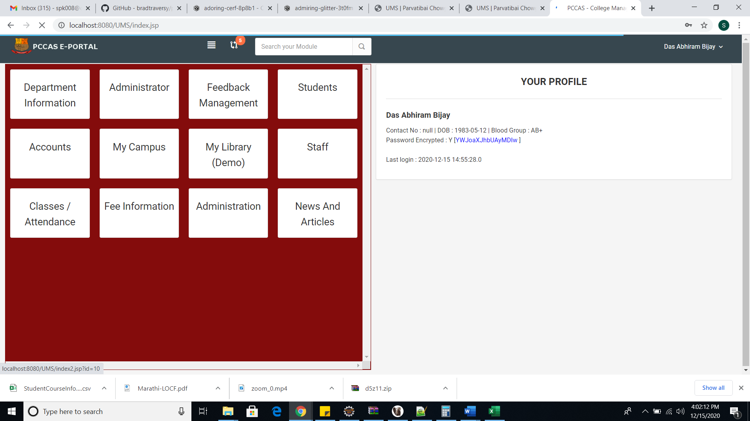

- After that click on queries ->Student Academic Information
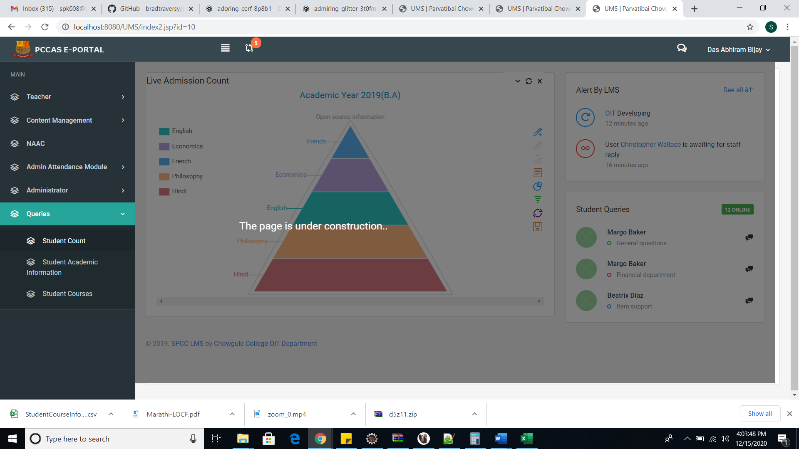

- Select Academic year , Course and Semester
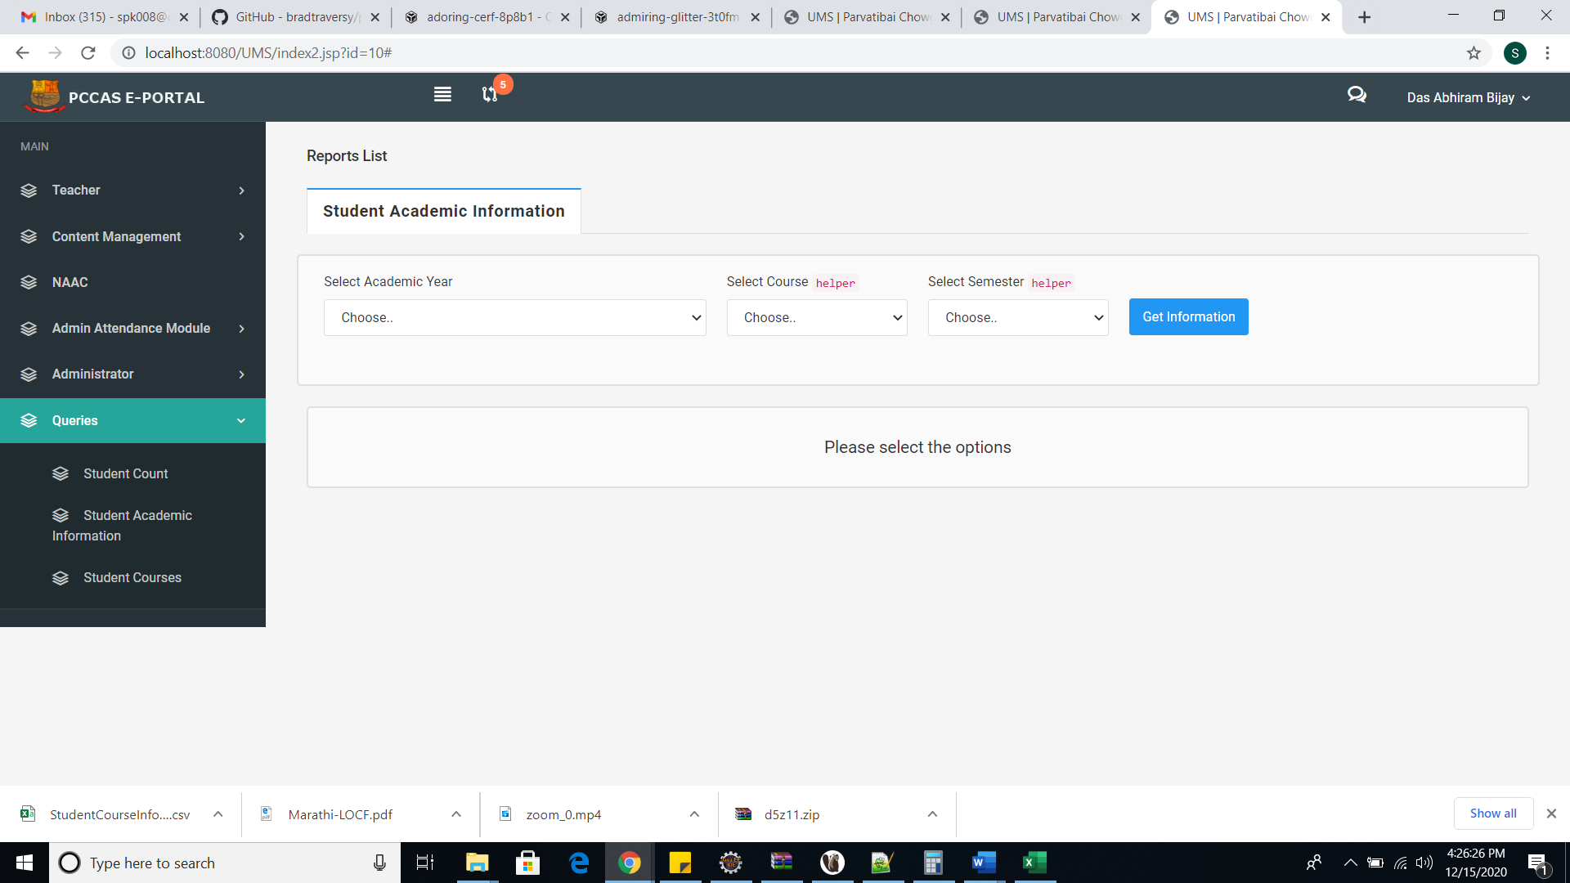

5)Click on Export to Excel to get data into excel sheet
