Manual To Check Students List given Feedback

- Login to UMS Portal
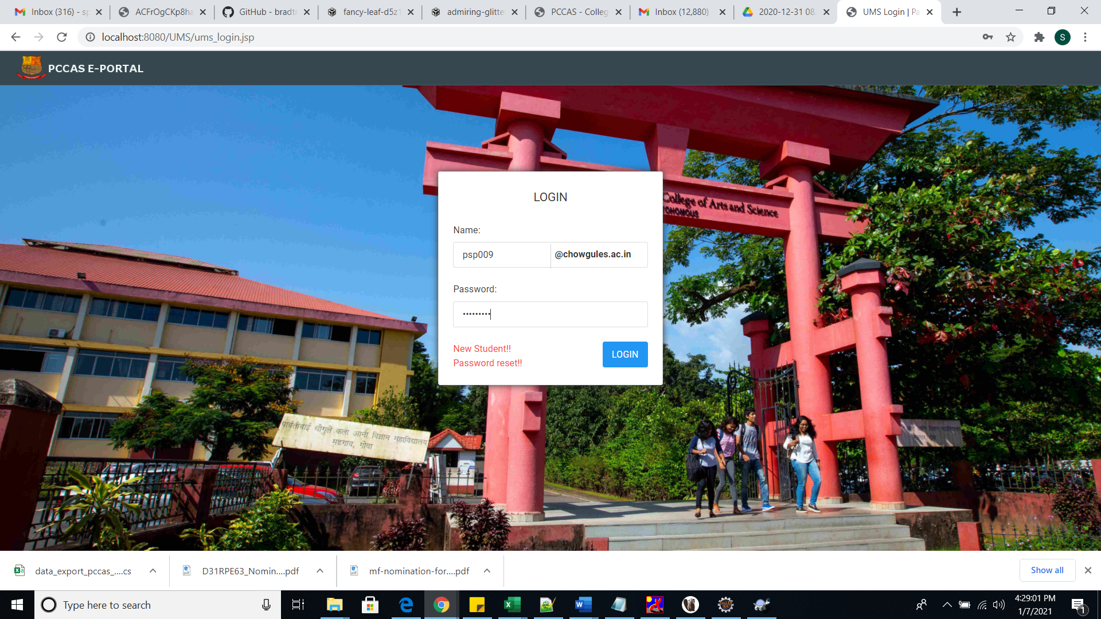

- After login go to Feedback Management Tab
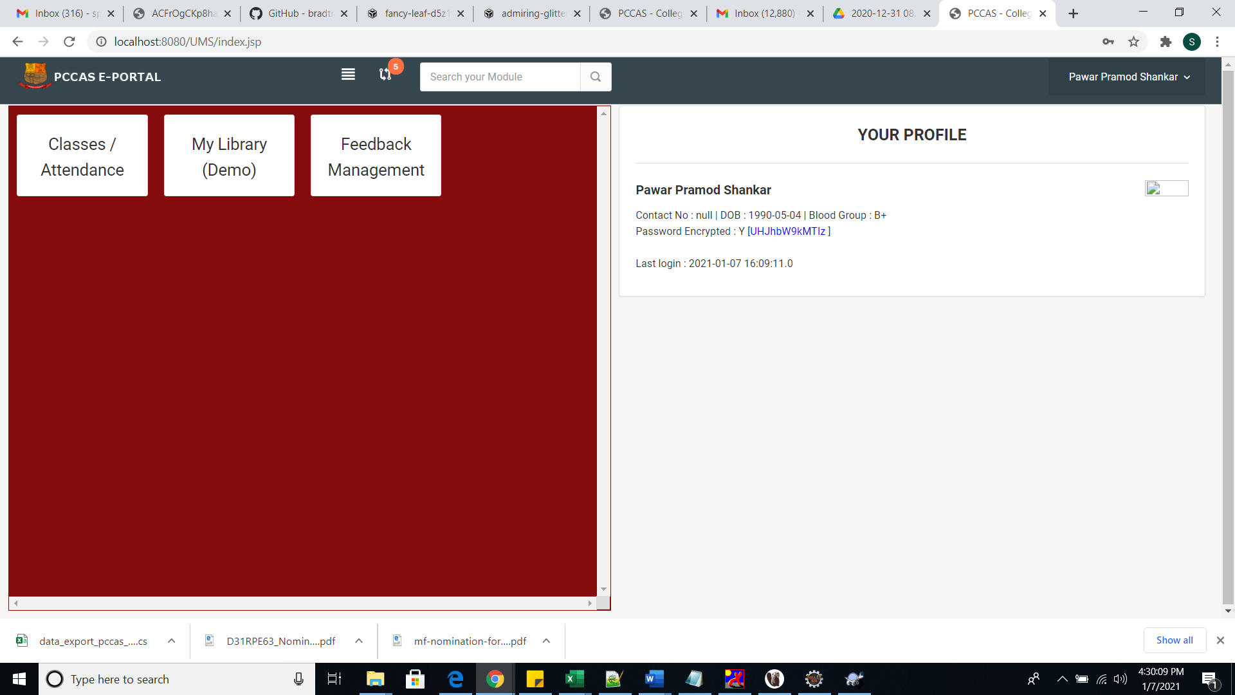
- Click on Setup -> Feedback you will get the data as shown below i.e. courses assigned to you
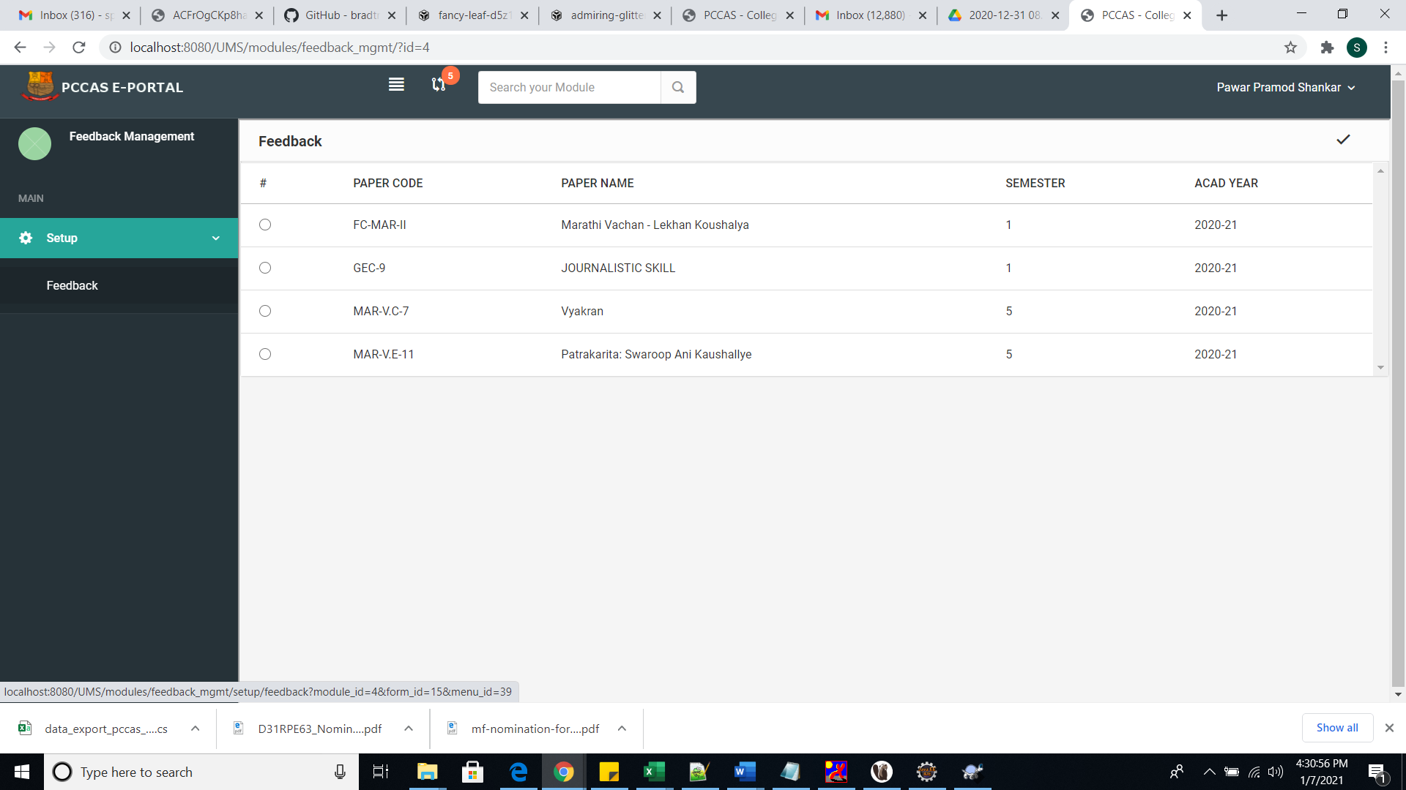

- Select the radio button and click on the tick mark to select that particular record
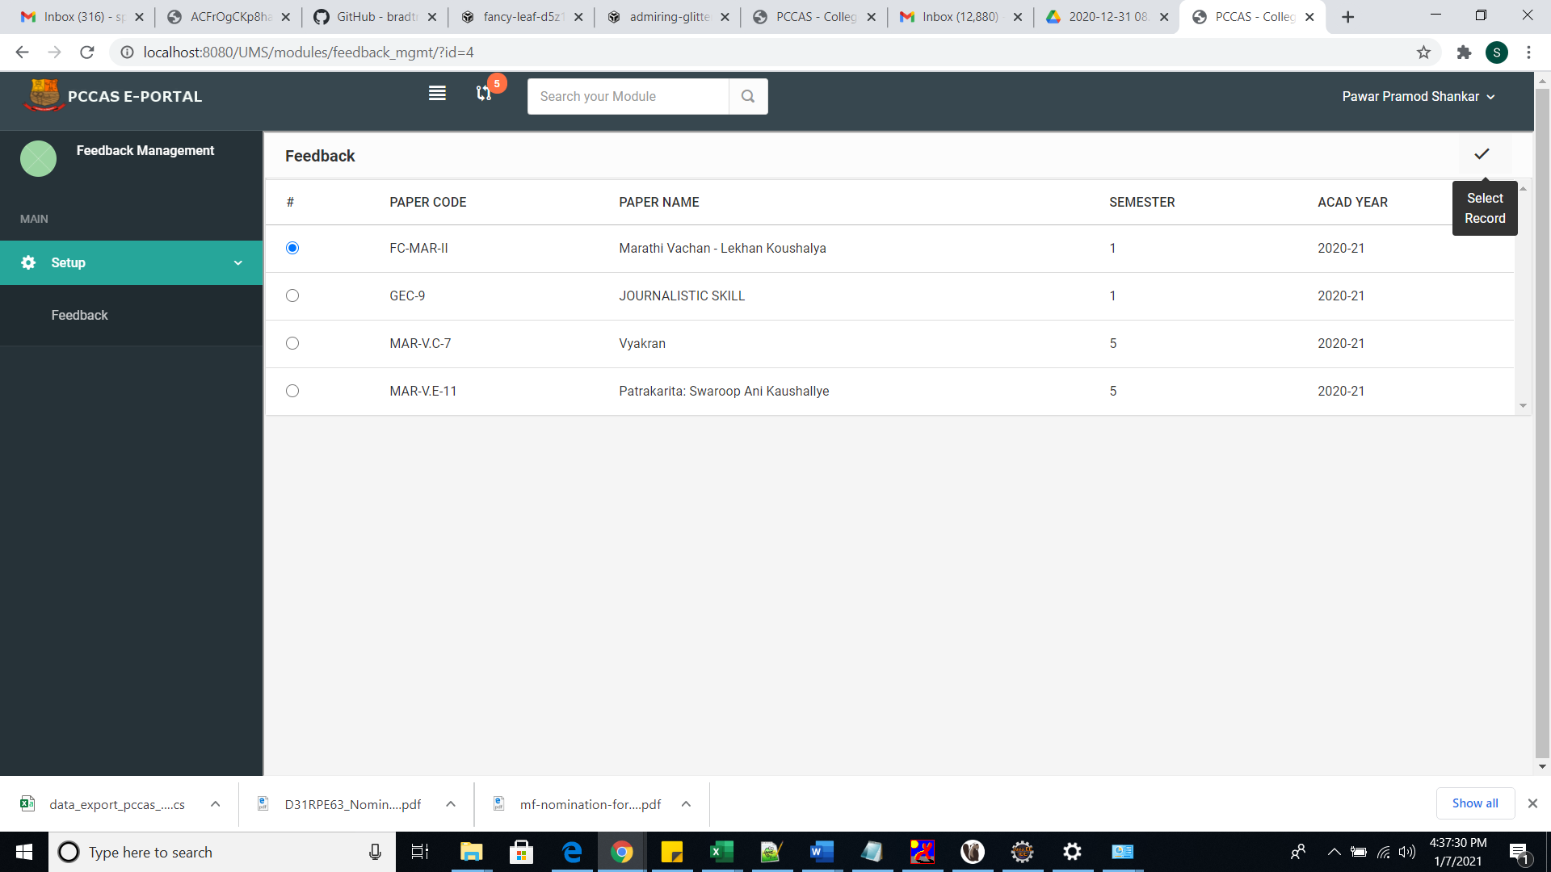

- You will see list of students who has given the feedback for that particular course
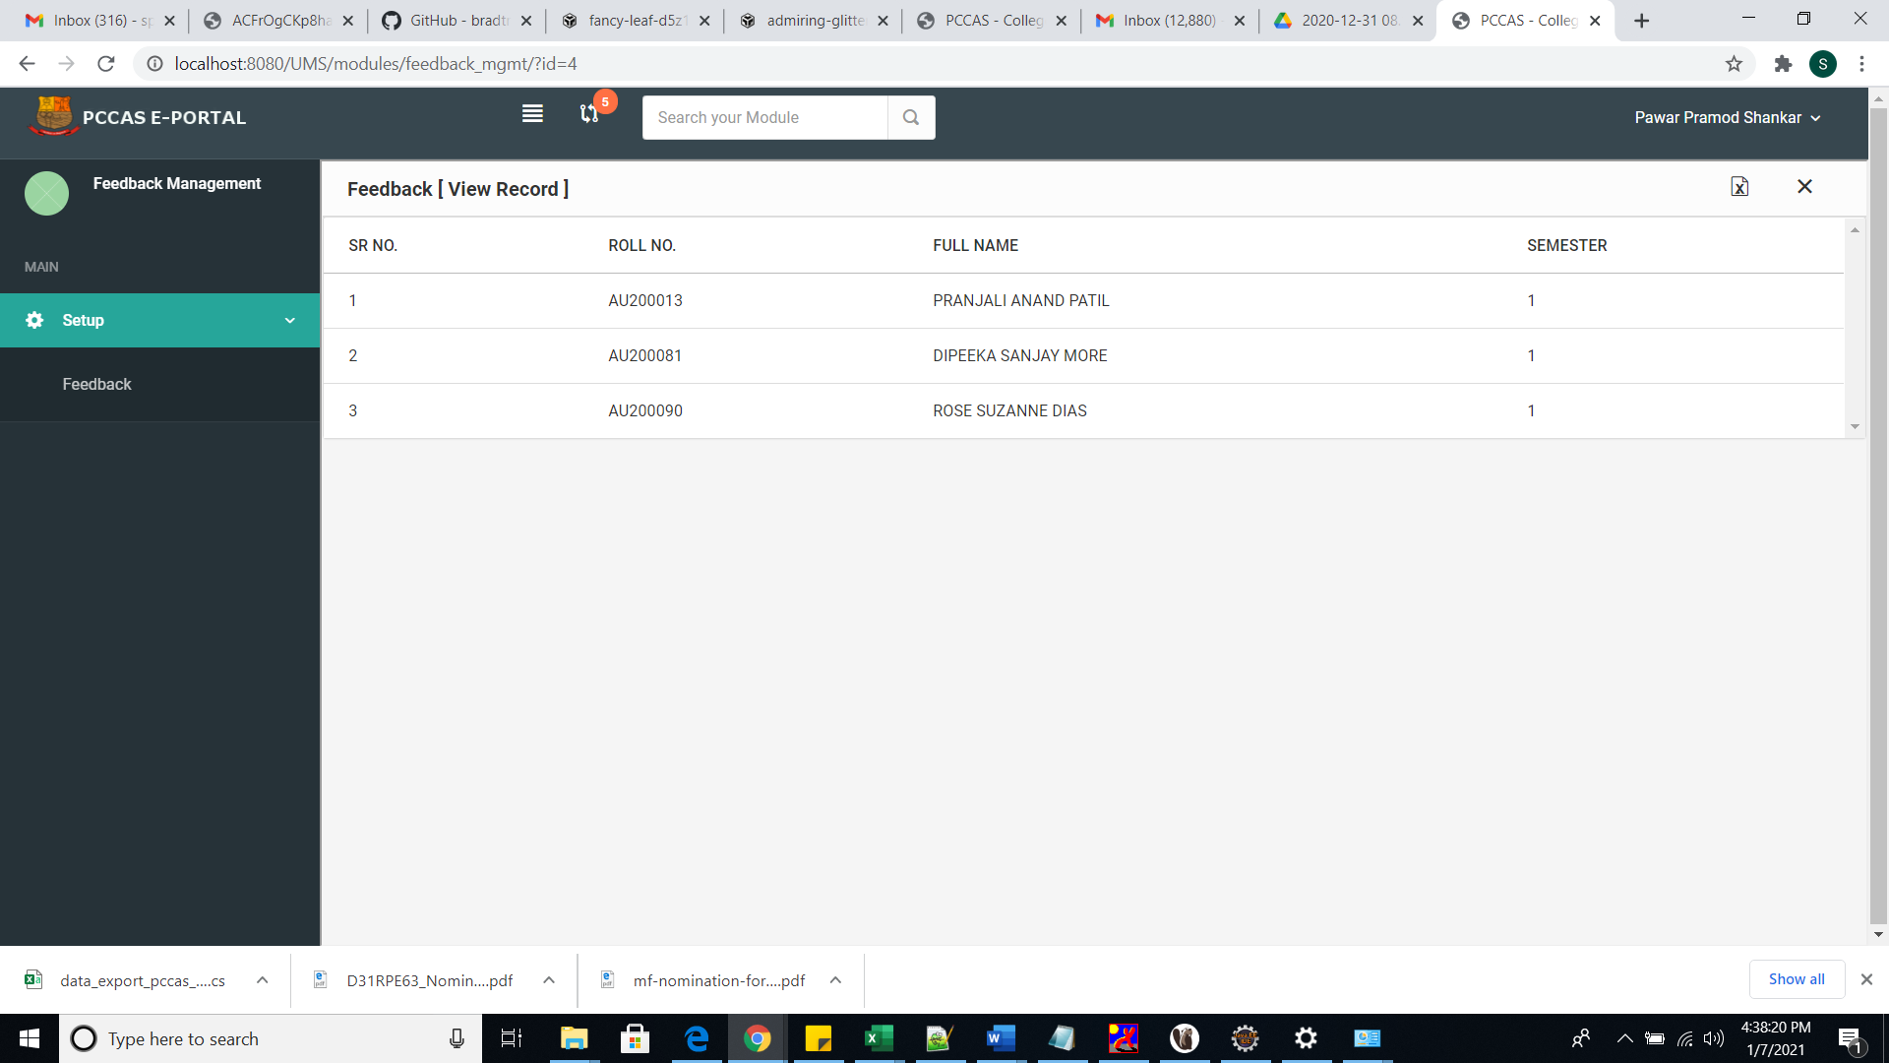

- To export data to excel click on the button as shown below in the screenshot and to close form click on cross mark
