DEPARTMENT OF GEOGRAPHY & RESEARCH CENTER
WORLD POPULATION DAY
- World Population Day was observed on 11th July 2017.

HIROSHIMA NAGASAKI DAY
- Hiroshima Nagasaki Day was observed on 9th August 2017 in remembrance of the atomic bombings of Japanese cities of Hiroshima and Nagasaki in 1945.

MoU ACTIVITY WITH GOA INSTITUTE OF PUBLIC ADMINISTRATION AND RURAL DEVELOPMENT (GIPARD), OLD GOA
- The Goa Institute of Public Administration and Rural Development (GIPARD), Ela, Old Goa in collaboration with Parvatibai Chowgule College, Margao, organized “One Day Awareness Programmes on Malnutrition, Anemia and Alcoholism” for Anaganwadi Workers on 9th August 2017, 11th August 2017 and 1st September 2017. Dr. Anagha Bicholcar coordinated the two programmes.
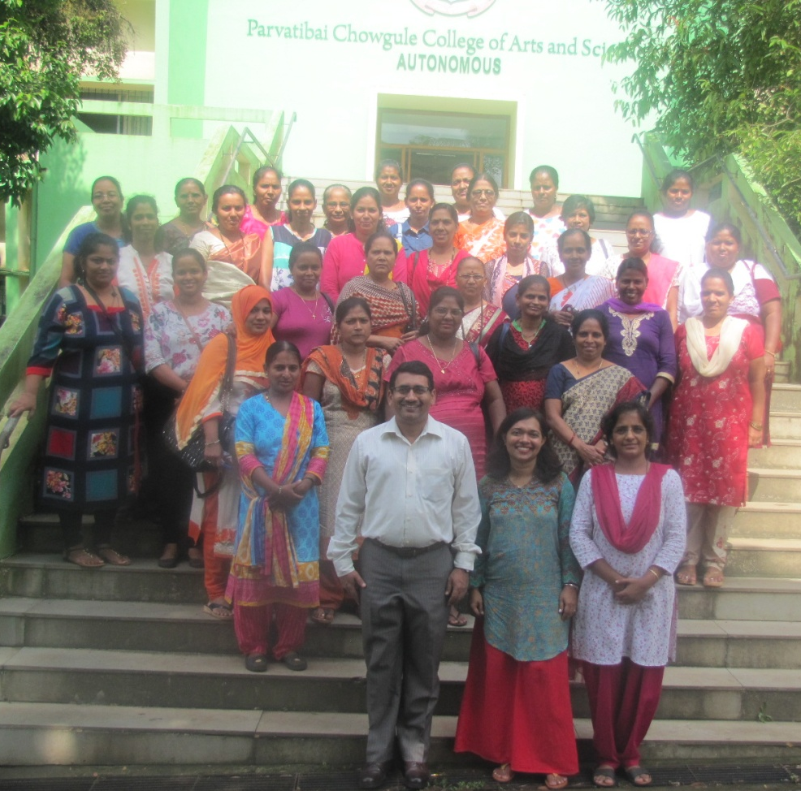
Participants of Training Programme on 9/8/2017 along with (L to R) Dr. N. N. Sawant (Principal), Ms. Vandana Kakodkar (Resource Person) and Mrs. Anagha Bicholcar (Coordinator)

BEST TEACHER AWARD
Dr. Nandkumar Sawant, Principal & Associate Professor, Department of Geography & Research Center was awarded the State Award for “Best Teacher” for the year 2016, by the Government of Goa, Directorate of Higher Education, Porvorim, Goa on 5th September 2017

