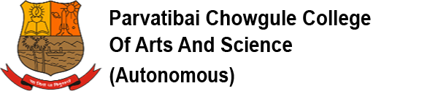
FIRST-YEAR UNDERGRADUATE STUDENTS -2020-21
ISSUE OF IDENTITY CARDS
Students of first-year Undergraduate students, who have paid their fees in full for the academic year 2020-21, are requested to collect their Identity cards from the College office, subject to submission of the following documents:
i) Students passed out from Goa Board/Colleges affiliated to Goa University
1. XII marksheet & Passing Certificate and/or marks sheet of last examination ( 2 self attested photocopies) – Original to be produced for verification
2. Leaving certificate / Transfer Certificate (original and one copy)
3. Birth Certificate (one copy)
4. Caste Certificate, if belonging to reserve category (one copy)
5. Passport size photograph (one)
ii) Students from other than Goa Board/Goa University
In addition to documents listed under (i) (1) (3) (4) (5) above, submit
1. Provisional Eligibility Certificate issued by this College
2. Transfer Certificate and Migration Certificate (original and one copy)
Schedule
First year BA/B.Voc. students : 3rd to 6th March 2021,
between 09.30 a.m. and 12.30 p.m.

First year B.Sc. : 8th to 10th March 2021
between 09.30 a.m. and 12.30 p.m.

Identity cards will be issued to students only on submission of above documents.
Dr.SHAILA R.GHANTI
Offg.Principal
February 23, 2021

