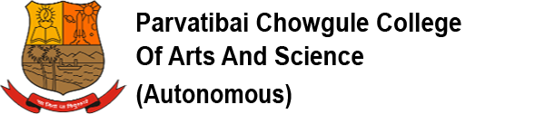

CONDUCT OF CLASSES FOR UNDERGRADUATE PROGRAMMES

In view of the directives received from the Goa University, following decisions have been taken, and, are to be adhered to:

1) Theory classes for all Programmes (B.A./B.Sc./B.Voc.) will be conducted only in online mode during the month of April 2021.

2) No practical will be conducted in offline mode for FY/SY B.A./B.Sc./B.Voc. w.e.f. 9th April 2021 until further notice.

3) Practicals for Final Year students of B.A./B.Sc./B.Voc. will be continued in offline mode.

4) Any Continuous Assessment scheduled during the month of April 2021 for all programmes to be conducted only in online mode.

April 08, 2021 Dr.SHAILA R. GHANTI
Offg. Principal

