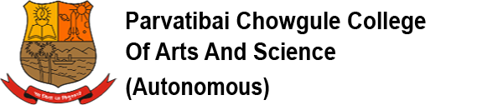.

GOA LIBERATION DAY CELEBRATION
(19th December 2020)

Flag Hoisting Ceremony will be held in front of the Fitness Centre on Saturday, 19th December 2020 at 9.00 a.m. sharp. Vice-Principal Shri. H. S. S. Nadkarni will unfurl the flag and address the gathering.

All the members of staff are requested to report at 8:45 a.m. sharp. Please note that college gate will be closed from 8.50 a.m. till the end of the flag hoisting ceremony. No staff member should leave during the function.

The teaching and non-teaching staff are requested to record their attendance on the biometric machine.

Date : 17th December 2020 VICE-PRINCIPAL

