COLLABORATIONS
Parvatibai Chowgule College believes in giving golabl exposing to the students. In addition to the breadth and depth of academic courses, the institution has developed formal collaborations and linkages with international, national and local organizations.

Linkages were also initiated with institutions, companies and industries for research activities and internships for students.

INTERNATIONAL COLLABORATIONS:
International exchange programs were developed in 2010 with an aim to provide opportunities to students to broaden their academic sphere and international perspective, get global experience, to exchange ideas and experiences with their counterparts in other countries.

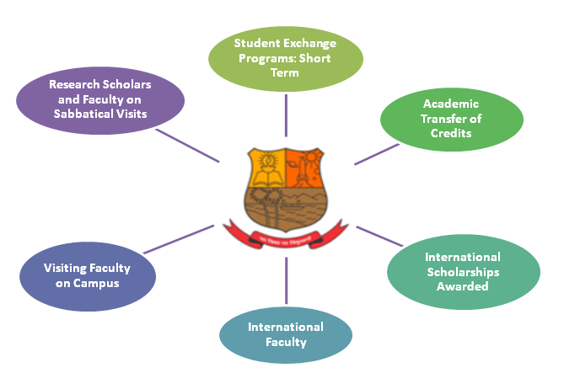

The college has long term and short term programs with the following International Universities/Institutions:

Country | Institution
 | Waseda University, Japan agreement signed for cultural and academic exchange and teaching and research
 | Kansai University, Japan agreement signed for academic and faculty exchange
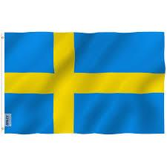 | Bromma gymnasium, Sweden agreement signed for cultural exchange
 | Tullinge gymnasium, Sweden agreement signed for cultural exchange
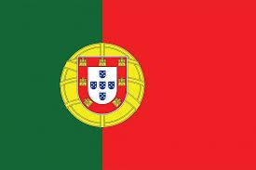 | University of Porto, Portugal agreement signed for short term, academic exchange and teaching and research
 | University La Reunion, agreement signed for faculty exchange and research
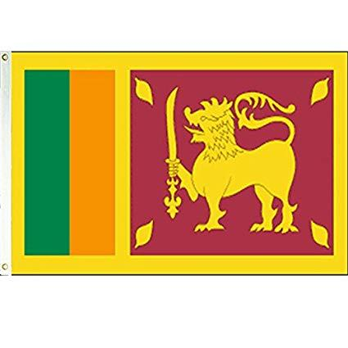 | Sri Lanka agreement signed for exchange program and collaborative research

Besides, the college has MoUs with Gogate Jogalekar College, Ratnagiri Maharastra; Parishkar College of Global Excellence, Jaipur; Mangrove Society of India, Sophia College Ajmer, Dahiwadi College, Satara;, Satara. MoUs with educational institutes in Goa include Carmel College of Arts, Science and Commerce, Nuvem; Govt. College of Arts and Science Quepem, MES College Vasco and Shree Mallikarjun and Chetana Manju college of Arts, Science and Commerce, Canacona Goa.

